** The information contained in this document is for Educational Purposes ONLY **
Loan Analysis for Satish Kumar
Current Baseline Loan Plan
Loan Amount: Rs. 2,00,00,000  Interest Rate: 8.50%  Loan Term: 20 yrs  Monthly EMI: Rs. 1,73,565 | Total EMI Paid at end of term: Rs. 4,16,55,515  Total Interest Paid at end of term: Rs. 2,16,55,515  Asset Value at end of term: Rs. 2,00,00,000

Net Cost of Loan: Rs. 2,16,55,515

Satish Kumar can pay Rs. 23,874 extra per month (Total of Rs. Rs. 1,97,439).
This amount is split between Loan EMI and monthly SIP to recover interest paid on Loan.
Loan Monthly EMI: Rs. 1,96,948
Monthly SIP Amount: Rs. 32,464
Total Monthly Amount: Rs. 2,29,412

Proposed Loan and SIP Analysis
Revised Loan Term: 15 yrs  Monthly EMI: Rs. 1,96,948 | Total EMI Paid at end of term: Rs. 3,54,50,624  Total Interest Paid at end of term: Rs. 1,54,50,624  Asset Value at end of term: Rs. 2,00,00,000

SIP Amount per month: Rs. 32,464  Expected Rate of Return: 12.00% | Total SIP Amount Paid: Rs. 58,43,515  Corpus Value at end of 15 years: Rs. 1,54,50,624  Corpus Value at end of 20 years: Rs. 2,72,29,279

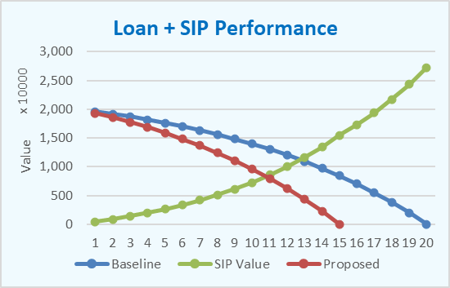

Cost Benefit Analysis

Net Cost of Loan + SIP: Rs. 4,12,94,139

Value of Assets in Hand: Rs. 2,00,00,000
Wealth Created through SIP: Rs. 2,72,29,279
Total Value of Asset + Wealth: Rs. 4,72,29,279

Savings in Money Paid: Rs. 3,61,376
Addt. Wealth Created: Rs. 2,75,90,655

Thank you for reviewing the customized Loan Analysis report. We appreciate your trust in Nivra Fintech and remain committed to providing high-quality, goal-oriented financial solutions. Please contact us should you require any further assistance.

Nivra Fintech LLC, Team!
The Financial Engineers

